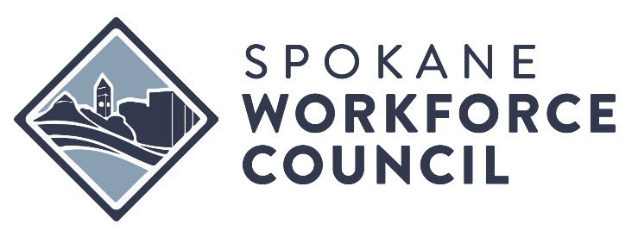

MEETING MINUTES  SPOKANE WORKFORCE COUNCIL  EXECUTIVE COMMITTEE | March 19, 2026  Meeting held virtually

MEMBERS PRESENT |  | STAFF PRESENT
Steve MacDonald |  | Kevin Williams
Christina Vigil Gross |  | Jeanette Facer
Tina Morrison  Kelley Charvet  Diana Wilhite  Kim Watkins  Ron Valencia |  | Jessica Clayton  OTHER  Angeles Jimenez  Alisha Shaw  Larissa Nolte
 |  | STAFF ABSENT
MEMBERS ABSENT
Mayor Lisa Brown
Comm. Josh Kerns
Patti Borchardt

Kimberly Watkins called the meeting to order at 12:00 P.M.

ITEM #1 – SAO Single & Financial Audit report for the fiscal year end 6.30.25
SAO
The meeting opened to establish quorum and conduct an exit conference with the State Auditor’s Office (SAO) to review the council’s financial statements and federal single-audit for July 1, 2024–June 30, 2025. SAO reported unmodified opinions on both the financial statements and federal grant compliance, no material misstatements or material weaknesses, one immaterial uncorrected item in the exit packet, no override-of-controls issues, and noted GASB 101 and GASB 100 changes; the COVID-19 Economic Adjustment Assistance Program represented about 21% of federal expenditures and the published report will be posted on the SAO website in one to two weeks.

ITEM #2 - REVIEW OF MEETING MINUTES
Kimberly Watkins - Board Chair

Review of February 19, 2026, Meeting Minutes.
Action: Motion and second to approve Meeting Minutes from February 19, 2026. Approved unanimously.

ITEM #3 – Grants and Contracts
Jessica Clayton, Division Executive Development & Program

Jessica Clayton described a $200,000 award for the Washington Jobs Initiative Healthcare Talent Pipeline Development Project with proposed subcontracting of $120,000 to Workforce Southwest Washington, $50,000 to Spokane consortium providers, and the remainder for administration; she confirmed funds flowed from the Department of Labor through state agencies and allocations reflect partnership commitments.
Action: Motion and second to approve vote to approve to authorize the SWC to accept $200,000 in additional funding for the Washington Jobs Initiative and subcontract $120,000 to Workforce Southwest Washington and $50,000 to the Spokane Workforce Consortium. Approved unanimously.

ITEM #4 – Activities & Updates
Jeanette Facer, Division Executive Finance
Kevin Williams, Division Executive System Advancement

Jeanette talked about partners agreement that needs to be done by March 31st, 2026. Jeanette also talked about some board members that will be introduced at the next full board meeting.

ITEM #5 – CEO Search Committee Update
Christina Vigil-Gross- Board Member

Christina presented two candidates as finalists for the CEO position. The internal Candidate is Kevin Williams and external is Sheryl Mcgrath. Meet & Greet scheduled for the April 8 full board meeting where both candidates will present and an executive committee vote planned for the 16th.
Action: Motion and second to approve Kevin Williams and Sheryl Mcgrath as the finalist for the CEO position. Approved unanimously.

Kimberly Watkins adjourned the meeting at 12:34 P.M.

