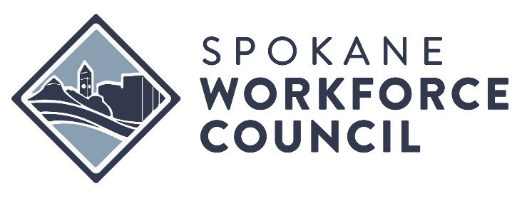

MEETING MINUTES  SPOKANE WORKFORCE COUNCIL  EXECUTIVE COMMITTEE | January 22 , 2026  Meeting held in person Ruby River Hotel

MEMBERS PRESENT |  | STAFF PRESENT
Ron Valencia |  | Kevin Williams
Christina Vigil Gross |  | Jeanette Facer
Tina Morrison
Kelley Charvet
Diana Wilhite
Kim Watkins |  | STAFF ABSENT
Patti Borchardt |  | Jessica Clayton
MEMBERS ABSENT
Mayor Lisa Brown
Comm. Josh Kerns
Steve MacDonald

Kimberly Watkins called the meeting to order at 12:00 P.M.

ITEM #1 - REVIEW OF MEETING MINUTES
Kimberly Watkins - Board Chair

Review of November 20th, 2025 & December 10th, 2025, Meeting Minutes.
Action: Motion and second to approve Meeting Minutes from November 20th, 2025 & December 10th, 2025. Approved unanimously.

ITEM #2 – Grants and Contracts
Jeanette Facer, Division Executive Finance

The State holds back a portion of WIOA Dislocated Worker funds each year that can be deployed when areas experience sudden economic hardships or layoffs. Jeanette Facer presented with Spokane is being awarded an additional $55,766 in Dislocated Workers funds. SWC is seeking approval to subcontract $50,189 to the consortium. The new Dislocated worker contract will be $1,204,361.

Action: Motion and second to approve vote to approve to bring in addition WIOA Dislocated Worker Funds in the amount of $55,766 and subcontracting out to consortium $50,189. Approved unanimously.

ITEM #3 – Accountability Audit Update
Jeanette Facer, Division Executive Finance
The Board of Directors received and reviewed the Washington State Auditor’s Accountability Audit Report for the Spokane Area Workforce Development Council covering the period July 1, 2021 through June 30, 2024, issued February 12, 2026. The audit examined the Council’s compliance with applicable state laws, regulations, internal policies, and the adequacy of controls over safeguarding public resources. Overall, the auditor reported that in most areas reviewed the Council complied with applicable requirements and maintained adequate controls.
The audit included review of payroll practices, accounts payable and credit card use, authority for contracted services, selected IT security controls, treasury activities and bank reconciliations, financial condition monitoring, and compliance with Open Public Meetings Act requirements.
The report included one finding stating that the Council provided certain workforce development consulting services outside of its statutory service area and used revenue generated from those services for expenses determined to be unallowable under state law governing public funds. Examples cited included commission bonuses based on formula of consulting services and holiday event expenses that did not meet constitutional requirements related to extra compensation and use of public funds.
Management acknowledged the finding and clarified that the Council previously believed certain revenues could be treated as unrestricted under nonprofit accounting practices. Management confirmed that the Council now recognizes all revenues must be treated as public funds subject to applicable governmental restrictions.
Management reported that corrective actions are being implemented, including establishing review procedures to ensure activities remain within statutory authority, requiring legal review for contracts that may extend outside the Council’s jurisdiction, revising procedures for revenue classification and compliance, updating policies related to bonuses and incentive compensation to ensure compliance with state requirements, and strengthening controls over meal, event, and related expenditures.
The Board discussed the report and management’s corrective actions and acknowledged receipt of the audit.
ITEM #4 – WorkSource Overhead Discussion
Jeanette Facer, Division Executive Finance
Kevin Williams, Division Executive System Advancement

The committee also explored financial implications stemming from increased overhead costs at the WorkSource Center and the potential for relocating to reduce expenses. Kevin Williams outlined the requirements for an American Job Center and proposed expanding micro sites to enhance community engagement. Discussions included the need for discretion in communications with the Employment Security Department and the importance of keeping the board informed.

ITEM #5 – Activities & Updates

Christina Vigil Gross provided an update on the hiring process for a new CEO, while Jeanette reported on a bipartisan agreement regarding WIOA funding, anticipating a manageable local impact despite a federal decrease. Diana Wilhite expressed her commitment to advocating for adequate funding during her upcoming visit to Congress.

Kimberly Watkins adjourned the meeting at 12:45 P.M.

